Discourse #21

Study the three artworks below. Explain why the Balloon Dog (Yellow) and Drink Canada Dry are every bit Pop Art as Andy Warhol’s Marilyn series. (One page)
Andy Warhol:
https://www.warhol.org/
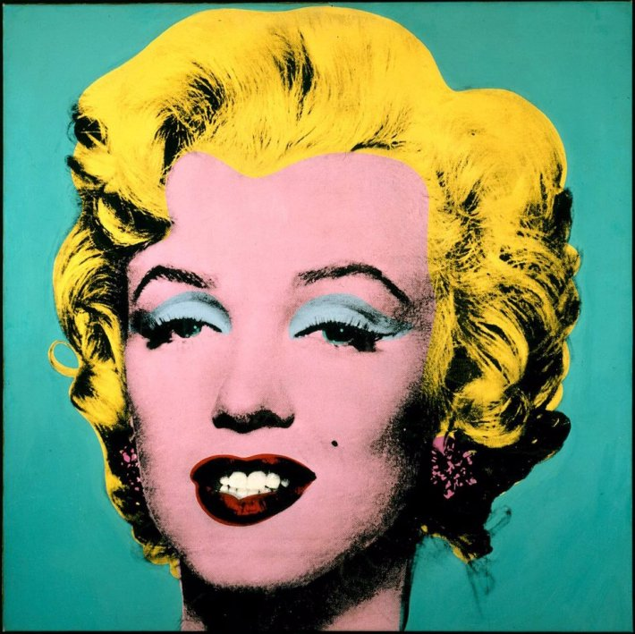
Turquoise Marilyn (1964)
Silkscreen

Art Dealers have been largely responsible for making artists famous. Names like Leo Castelli and Ivan Karp (who I knew well before his death several years ago) are names well known in the art-world. Leo Castelli and Ivan Karp worked together to promote the Abstract Expressionists before Karp opened his own gallery OK Harris in SoHo where he promoted Andy Warhol and many other Pop artists. Art is a business and these men not only made these artists wealthy, but they became wealthy too.

https://www.sfmoma.org/artist/Jeff_Koons
http://www.nytimes.com/2008/04/22/arts/design/22koon.html

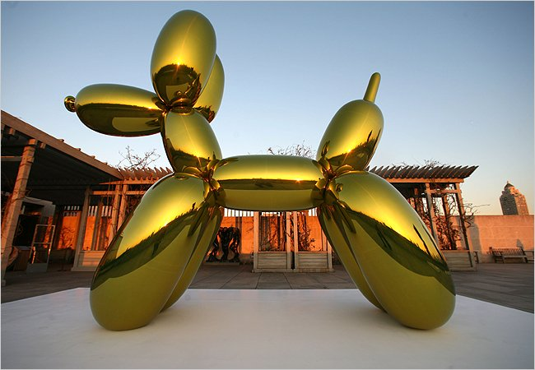
Balloon Dog (Yellow)
Stainless Steel

Richard Prince:

http://taggedwiki.zubiaga.org/new_content/7f2805f27f79adf0892af60b95c0dd0b
I usually don’t promote Wikipedia, but I know Richard Prince and his work so well and can endorse this particular link. I was fortunate enough to have visited Richard Prince’s studio many times over a ten year period. My former husband built art stretchers for him including his car hood/stretcher combinations.

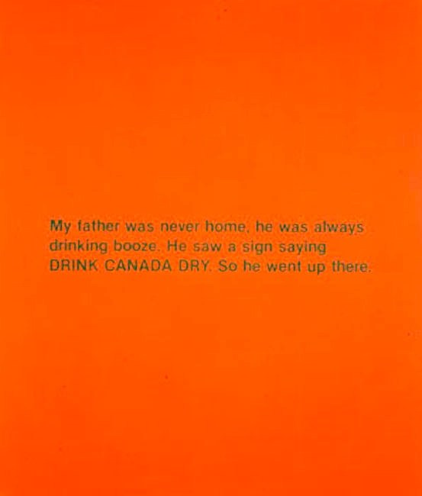
Drink Canada Dry (1980s)
Silkscreen and Acrylic on Canvas (192x147 cm)

